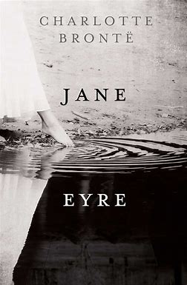
Year 9 DEAR

Term 1 book: Charlotte Bronte’s “Jane Eyre”
- To explore a pre-1914 novel.
- To read quality, seminal literature to explore life in the 19th century.
- To understand the way children and women were treated historically.
- To understand the horrors of the care and education system in the 19th century.
- To provide opportunities for oracy; discuss how views around mental health have changed over time.
- To build empathy with characters who endure challenging lives.

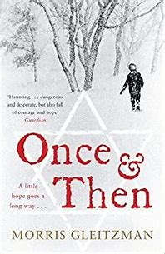

Term 2 book Morris Gleitzman’s “Once and Then”
- To explore ideas surrounding the Holocaust and the effect it had on victims and their families.
- To read a modern book (2005) by an Australian author.
- To provide opportunities for oracy; discussion of historical treatment of the Jews.
- To develop cultural capital in terms of historical context, religious acceptance and human rights.
- To discuss discrimination in its many forms and to challenge preconceptions.
- To develop empathy with people from other faiths and cultures.

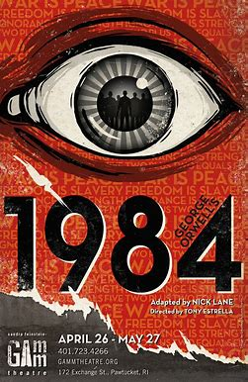

Term 3 book: George Orwell’s “Nineteen Eighty-Four”
- To explore dystopian, seminal text from 1949.
- To provide opportunities to discuss the consequences of totalitarianism, mass surveillance, and repressive regimentation of persons and behaviours within society.
- To explore and understand the origins of some ideologies and fears including room 101 and societal fears of surveillance cameras.
- To provide opportunities to read a book by an author synonymous with criticism of the lives of the working class connected to the local area: “The Road to Wigan Pier”.

