Science: Inheritance and Classification

- Variation
Organisms within a species have variations.
Inherited variation |  | Environmental variation
Variations caused by genes gained from parents |  | Variations caused by surroundings
Examples |  | Examples
Eye colour |  | Scars
Blood group |  | Accent
Sex |  | Length of hair
Some variations are both inherited and environmental; height, weight, skin tone, intelligence
Key words
Variation | The differences in characteristics between living things
Species | A group of organisms that are very similar to each other and can produce fertile offspring
Characteristics | The individual differences between organisms

Challenge Questions
1 | Why do you think animals and plans are sorted into groups?
2 | Describe why identical twins are only genetically identical
3 | Explain the adaptations of organisms to prevent being eaten
4 | Why do you think climate change is affecting the population numbers of polar bears?

- Continuous and discontinuous variation
Continuous variation | Discontinuous variation
A characteristic that changes gradually over a range of values | A characteristic that has a limited number of possible values
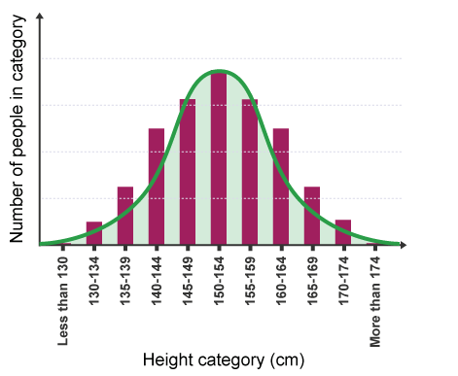 | 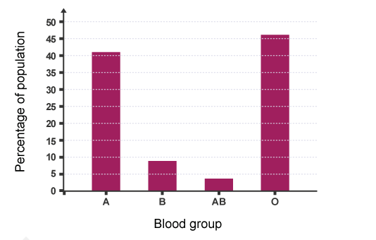

- Genes
Key words
DNA | Genetic information. It has all the instructions a living organism needs to grow, reproduce and function
Gene | A small section of DNA that has the genetic code for a specific characteristic
Identical twins |  | Non identical twins
From a single egg fertilised by a single sperm that splits in half before implantation |  | From separate eggs that were released at the same time and fertilised by separate sperm
They have the same DNA code and will be the same sex |  | They have different DNA code so can be different sexes

Science: Inheritance and Classification

- Adaptations
Organisms have special features that make them suited to their environment
 | Adaptation | How it helps it to survive
1 | Waterproof fur | Prevents the cold water toughing the skin
2 | Large wide feet | Prevents sinking in the snow
3 | Small surface area to volume ration | Reduces heat loss from the skin
4 | White fur | Camouflages it against the snow so it can hunt prey
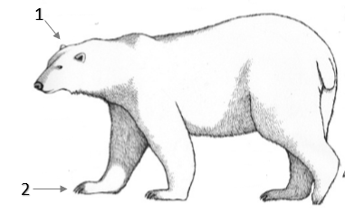
1
4
3
2

- Plant reproduction
1 | Petal | Attracts insects for pollination | 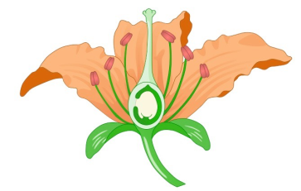  4  3  2  1
2 | Anther | Covered in pollen
4 | Stigma | Captures pollen from other plants
5 | Ovary | Where fertilisation takes place

- Classification
Key Word | Definition
Vertebrate | An animal that contains a back bone
Invertebrate | An animal that does not contain a back bone
The vertebrates can be split into 5 main groups
Group |  | Common Features
Mammal |  | Warm blooded  Feed young with milk  Internal fertilisation  Fur covered skin
Reptile |  | Cold blooded  Hard scaly skin  Lays leathery shelled eggs
Fish |  | Cold blooded  Slimy scales  Gills  External fertilisation of soft jelly eggs
Amphibian |  | Cold blooded  Slimy skin  External fertilisation of jelly like eggs
Bird |  | Warm blooded  Lays hard shelled eggs  Wings  Feathers

