Year 8 – DEAR
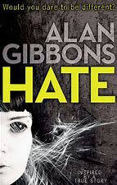

Term 1 book: Alan Gibbons’ “Hate”
- To read and explore a book about a recent true event (The death of Sophie Lancaster in 2007).
- To explore Hate Crime and the impact it can have on victims, their families and wider society.
- To provide opportunities to use oracy to discuss and explore the effects of Hate Crime in all its forms. To explore the wider impacts of Hate Crime on society.
- To develop empathy through characters that are based on real events.
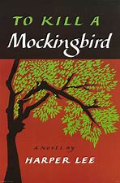

Term 2 Harper Lee’s “To Kill a Mockingbird”
- To become familiar with and understanding of the events around the Civil Rights movement in America 1960.
- To explore and challenge the prejudicial views people have against anyone who is different to themselves.
- To enhance pupils’ cultural understanding.
- To explore black rights texts in response to Black History Month.
- To show how knowledge and understanding can be enhanced through reading fiction; develop cultural capital in the areas of geography, history, citizenship and human rights.
- To introduce pupils to classic, seminal texts to expand their cultural capital and understanding of the wider world of literature.

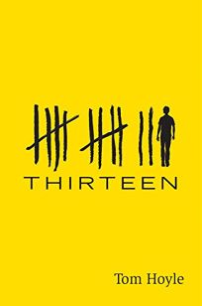

Term 3 Tom Boyle’s “Thirteen”.
- Provide opportunities to discuss adoption.
- To read the first book in a series to encourage pupils to reach out to other books to complete the full narrative.
- To include a modern, prize-winning book that covers the lives of teenagers in the modern world.

