Year 7 - DEAR
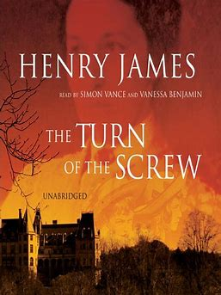

Term 1 book: Henry James’ “Turn of the Screw”
- To expose pupils to gothic genre and Victorian text.
- To develop empathy with characters.
- To develop imagination and response to writer’s thoughts and feelings.
- To expose pupils to pre 1914 texts.
- To widen pupils’ historical knowledge of the way people used to live.
- To provide opportunities for discussion around the idea of ghosts and human’s reactions to things we do not understand.

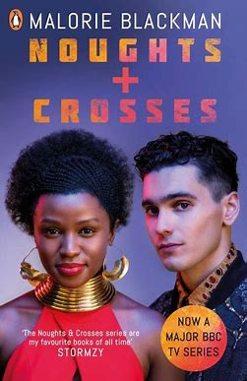

Term 2 book: Malorie Blackman’s “Noughts and Crosses”
- To expose pupils to dystopian texts.
- To explore the theme of racism and provide opportunities to discuss and challenge racism in society.
- To challenge racial stereotypes.
- To read a seminal text by a black author.
- To explore texts that relate to the zeitgeist.
- To build on work done around Black Right’s month.
- To provide a text that is above chronological reading age of pupils to stretch and challenge pupils’ reading ability, to read a book that matches the ability of those with reading ages above chronological RA.

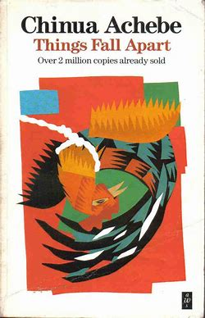

Term 3 book: Chinua Achebe’s “Things Fall Apart”
- To explore a text by an author from a different cultural background.
- To expose pupils to life from a different time and culture: set in pre-colonial Nigeria in 1958.
- To explore what we can learn from the proverbs of another country and how stories/proverbs can be interwoven into other stories.
- To widen pupils’ cultural and historical knowledge and understanding of other countries and cultures.

