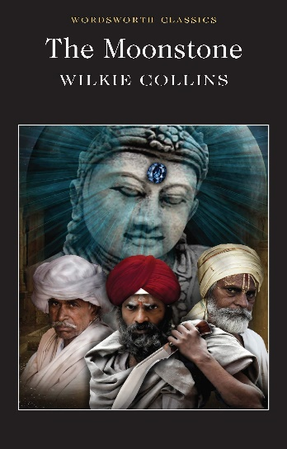
Year 10 DEAR

Wilkie Collins’ “The Moonstone” (1868)
- To read seminal, Victorian literature that is considered the precursor of the detective novel.
- To explore a book with an unusual structure; an epistolary novel.
- To explore the work of one of Dicken’s friends and fellow writers.
- To provide opportunities for oracy; discuss the arrogance of some British soldiers during their time in India, colonialism and British views around other faiths and cultures.
- To explore views around standing in society and the rights and lives of the working class compared to the upper class.
- To explore Collins’ presentation of strong female characters in a time when women had few rights and were considered inferior to men.
- To consider how people are judged on looks and status rather than characteristics.

