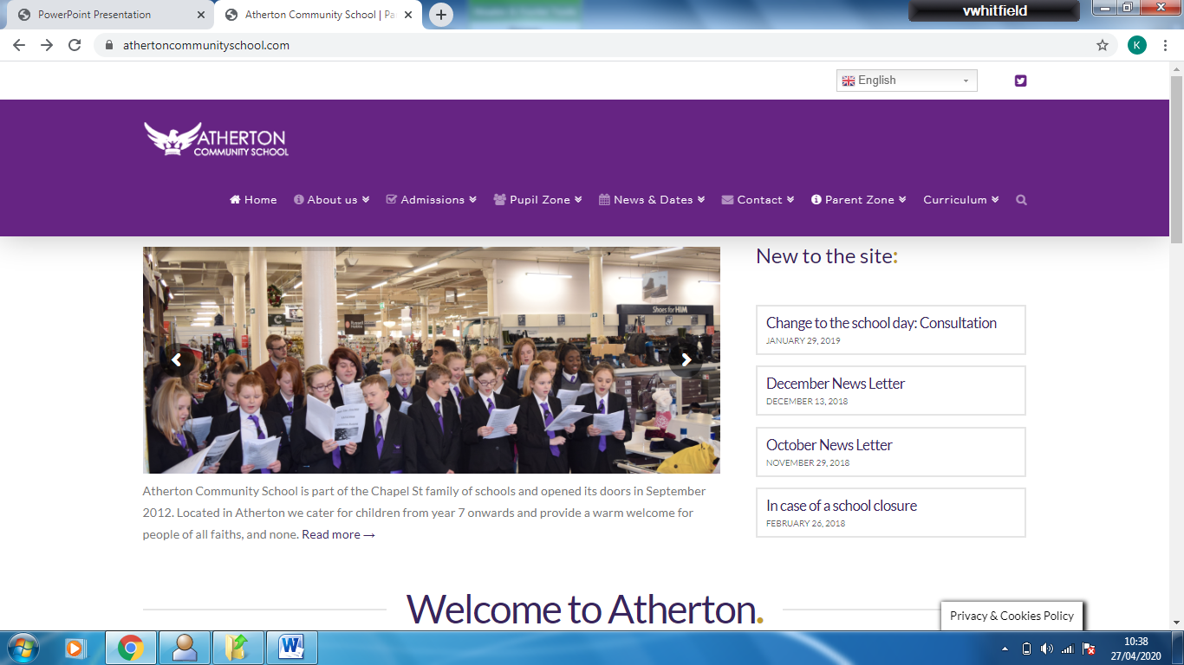

**Science: GCSE Variation, Inheritance and Evolution**

|  |  |  |
| --- | --- | --- |
| 1. DNA | | |
| 1 | Nucleus | Organelle that contains the genetic material |
| 2 | Chromosomes | Long molecule of DNA that comes in pairs |
| 3 | DNA | Sequence that codes for the |
| 4 | Gene | Single section of DNA that is responsible to specific characteristics |
| 4  3  2  1  Cell | | |

|  |  |  |
| --- | --- | --- |
| 1. The Human Genome Project | | |
| Genome | The entire sequence of the genetic material in an organism | |
| Human Genome Project | 25 year research project that mapped the entire human genome to identify specific locations of the genes each chromosome. | |
| **Application** | | **Advantage** |
| Genes linked to genetic diseases can be identified | | Gives a better understanding of how genetic diseases are inherited, so effective treatments can be developed |
| Tiny differences in peoples genomes can be studied | | Helps to trace migration patterns of past human populations |

|  |  |
| --- | --- |
| 1. Cell Division in humans | |
| **Mitosis** | **Meiosis** |
| Used for growth and repair | Used in the production of gametes |
| Once cell division per cycle | Two cell divisions per cycle |
| Daughter cells contain 46 chromosomes | Daughter cells contain 23 chromosomes |

|  |  |
| --- | --- |
| 1. Key Words | |
| Gamete | Sex cell |
| Allele | Single gene from a gene pair |
| Genotype | Coding used for a characteristic |
| Phenotype | Description of the chearacteristic |
| Dominant | An allele that is always expressed |
| Recessive | An allele only expressed when there are 2 recessive genes present |
| Homozygous | Alleles code for the same characteristic |
| Heterozygous | Genes code for different characteristics |
| Sexual reproduction | Fusing of nuclei from gamets, produces variation |
| Asexual reproduction | One parent, produces genetically identical offspring |
| Mutation | A random change in the sequence of DNA |
| Variation | Changes in a population caused by a mutation (differences in phyisical, chemical and behavioural characteristics between organisms or individuals) |
| Genetic variation | Variation that is caused by the inheritance of alleles of genes |
| Environmental variation | Variatio that is caused by the effects of environmental factors |



**Science: GCSE Variation, Inheritance and Evolution**

|  |  |
| --- | --- |
| 1. Determining Gender | |
| Female Genotype | XX |
| Male Genotype | XY |
| Each time an egg is fertilised there is a 50% chance it will be a girl. |  |

|  |  |
| --- | --- |
| 1. Inherited diseases | |
| Cystic Fibrosis | Caused by a recessive gene  Affects the cell membrane formation, causing mucus to build up in the lungs and digestive tract |
| Polydactyly | Caused by a dominant gene  Causes an extra digit to grow on the hand or feet |

|  |  |
| --- | --- |
| 1. Embryo Screening | |
| This is where one cell from an embryo is taken and the DNA is checked for the presence of specific genes | |
| **For** | **Against** |
| It will help prevent people suffering | Screening is expensive |
| Treating disorders costs the government a lot of money | People might want to screen embryos so they can pick the most ‘desirable’ trait |
| There are laws to stop the procedure being misused | Ethical issues as embryos found with genetic disorders are often destroyed (killing potential life) |

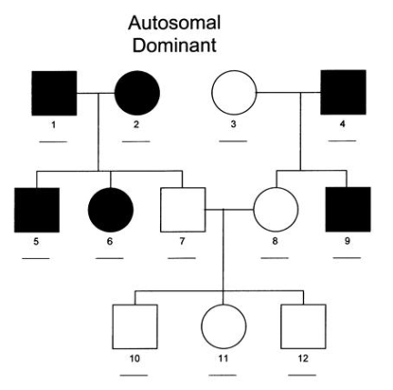

**Key**

Male without disorder

Female without disorder

Female with disorder

Male with disorder

|  |  |
| --- | --- |
| Challenge Questions | |
| 1 | What is the function of DNA? |
| 2 | Compare sexual and asexual reproduction |
| 3 | How does the diagram above show that this is a recessive disorder? |
| 4 | Evaluate the statement – *‘if parents 3 and 4 have another baby, there is a 50% chance of having a child with the disorder’* Justify your answer |



**Science: GCSE Variation, Inheritance and Evolution**

|  |  |  |  |
| --- | --- | --- | --- |
| 1. Evolution | | | |
| The theory of EVOLUTION by NATURAL SELECTION was put forward by Charles Darwin | | | |
|  | Stage | | Explanation |
| 1 | Variation | | There is genetic variation within a population caused by inherited genes |
| 2 | Competition | | Over production of offspring leads to increased competition |
| 3 | Selection | | Individuals with beneficial adaptations are more likely to survive to pass on their genes |
| 4 | Inheritance | | Over many generations there is a change in the allele frequency |
|  | | | |
| Species | | A group of organisms that have similar features that can breed to produce fertile offspring | |

|  |  |
| --- | --- |
| 1. Extinction | |
| What is extinction? | When the all the organisms of a species have die and there are none left alive |
| Causes of extinction | 1. NEW disease 2. NEW predator 3. Lack of food 4. Climate change 5. Natural disasters |

|  |  |
| --- | --- |
| 1. Fossils | |
| What are fossils? | Remains or imprint of an organism that dies millions of years ago, found in rocks, ice and peat |
| How do fossils form? (rocks) | 1. Organism dies and falls to the ground 2. Layers of sediment over the dead organism 3. Over millions of years, the layers turn to rock and minerals in the rock replace the minerals in the bones of an animal   This happens because decay cannot occur. |
| What information can fossils tell us? | Early life was simple.  The evolution of a species can be predicted by looking at differences between the fossils of a species. |
| Why do we not have fossils for the early life on Earth? | Fossilisation is rare as most organisms decay  Fossils can be easily become damaged as the rocks move due to tectonic plates  Most early life has soft body forms which do not fossilise |

|  |  |  |
| --- | --- | --- |
| 1. Classification | | |
| Carl Linnaeus | Developed the system of classification used today | |
| Binomial name | Official name of a species including the genus and species name | |
| 3 domain system developed by Carl Woese | All organisms can be classified in to 3 domains   * Archaea – ancient simple bacteria, often extremophiles * Prokaryote – bacteria * Eukaryote – complex organisms including animals and plants. | |
| **Group** | | **Mnemonic** |
| Kingdom | | King |
| Phylum | | Philip |
| Class | | Came |
| Order | | Over |
| Family | | For |
| Genus | | Good |
| Species | | Soup |



**Science: GCSE Variation, Inheritance and Evolution**

|  |  |  |
| --- | --- | --- |
| 1. Genetic engineering | | |
| Genetic Engineering (Genetic Modification – GM) | | Process of inserting the gene of one organism to the DNA of another to change or enhance specific characteristics. |
| Plasmid | | Ring of secondary DNA in a bacteria cell |
| **Genetically engineering insulin using bacteria (HT only)** | | |
| 1 | Chromosome containing desired gene is removed | |
| 2 | Plasmid from a bacteria is removed | |
| 3 | Enzymes are used to cut the gene from the DNA | |
| 4 | Enzymes are used to cut out a section of the plasmid DNA | |
| 5 | The desired gene is inserted in to the plasmid using enzymes | |
| 6 | The plasmid is placed back into the bacteria, which multiplies rapidly, copying the gene and making insulin | |
| 1  5  4  2  3  6 | | |

|  |  |  |
| --- | --- | --- |
| 1. Selective Breeding | | |
| Process of selecting individuals of the same species with the desired characteristic and breeding them to produce offspring with the desired characteristics | | |
| Benefits of selective breeding | | Produce disease resistant crops, increase the yield of milk and meat from cattle, increased growth rate of chickens so meat can be sold earlier, domestication of pets (more attractive and docile) and many more |
| Concerns of selective breeding | | It does not always work and takes a long time. Interbreeding of organisms can cause disease or defects |
| **Method for selective breeding** | | |
| 1. | Select a male and female with the desired characteristics | |
| 2. | Breed together | |
| 3. | Check the offspring for the desired characteristics | |
| 4. | If desired characteristics are present continue to interbreed until the characteristic is always present. If the desired characteristic is not present, go back to step 1. | |

|  |  |
| --- | --- |
| Challenge Questions | |
| 1 | Why might people not agree with the use of GM crops as food sources? |
| 2 | Why are bacteria used in genetic engineering of human proteins? |
| 3 | Explain how a cactus with small spines may have evolved from an ancestor with larger leaves. |
| 4 | Compare the information gained from ice fossils compared to the information gained from fossils formed in rocks. |