Science: GCSE Using Resources

- Key Words
Finite resource | A resource that will eventually run out
Renewable resources | Resources that reform at a similar, or faster, rate that we use them
Life Cycle Assessment (LCA) | An assessment of the environmental impact of a product over each stage of its life
Sustainable development | Meeting the needs of the present society whilst not damaging the lives of future generations

- Life Cycle Assessments
These are often used to determine the most environmentally viable option in production of a product.
LCA Stage | Plastic bag | Paper bag
Raw Materials | Crude oil | Timber
Manufacturing and packaging | Key components extracted by fractional distillation. Waste has other uses | Takes lots of energy to pulp timber and creates lots of waste
Using the product | Reusable | Single-use
Product disposal | Recyclable, not biodegradable | Biodegradable and recyclable

- Extracting Copper
Copper is a finite resource that is becoming scarce
Sustainability can be improved by extracting copper from low grade ores
Phytomining | Plants are grown in copper rich soils  The plants absorb the copper and levels build up in the leaves  Crops are harvested and burned to leave ash containing copper compounds  Copper is extracted using a displacement reaction with scrap iron.
Bioleaching | Bacteria are used to convert the copper compounds in the ore into soluble copper compounds  The copper is then extracted using electrolysis

- Recycling
Recycling helps to save on the large amounts of energy required to extract and process natural resources.
Material | Process | Extra Info
Recycling metals | Waste metals are melted down and recast into new products | Amount of separation required for the recyclable metal depends on the metal and the final product
Recycling glass | Waste glass is separated in to colours, crushed and melted  This is then reshaped in to new products | Glass bottles can also be washed and sterilised and used again instead of recycling them

Science: GCSE Using Resources

- Treating Water
Key Word |  | Definition
Potable water |  | Water that is safe to drink
Pure water |  | Water that contains only water molecules
Ground water |  | Water from underground rocks and rain
Treating ground water to produce potable water:
1 | Passed through a mesh that removes larger debris such as twigs and stones
2 | Passed through a filter to remove any smaller solid bits
3 | Water is sterilised to kill off any harmful microbes using chlorine, ozone or UV light
There are two methods of treating salt water to produce potable water:
Distillation |  |  | Reverse osmosis
Water is boiled and the condensed to remove the salt |  |  | The water is passed through a membrane that only allows water molecules through

Life cycle stage of a pillow case | Lifetime energy use (%)
Raw materials | 10
Manufacture | 15
Use | 70
Disposal | 5

Challenge Questions
1 | What do humans use natural resources for?
2 | How can sustainability be improved?
3 | Why might extracting metals form low grade ores desirable?
4 | Evaluate the use of energy in the lifecycle of a pillow case and suggest how the energy use could be reduced

- Waste Water Treatment
1 | Screening | Large waste products are removed such as paper
2 | Sedimentation | Tiny particles settle to the bottom of a still tank that then splits in to two sections effluent and sludge
3 | Aerobic digestion of organic matter | The effluent is treated with aerobic bacterial to reduce the volume of solid waste
4 | Anaerobic digestion of organic matter | The sludge is digested anaerobically by specific bacteria
5 | Released back into the environment | The treated effluent is returned to rivers and water ways
6 | Natural gas | Methane gas is produced from the anaerobic digestion of sludge and can be used as a fuel
7 | Fertiliser | The remaining sludge is rich in minerals and can be used as a natural fertiliser
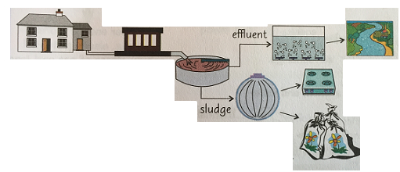
1
4
3
2
5
7
6

