Science: Particles and Separation Techniques

- States of matter
The particles of a substance do not change but the arrangement of the particles are different in each state of matter
Solid | Liquid |  | Gas
Comparing Properties
Property | Solid | Liquid |  | Gas
Fixed shape
Fixed volume
Can be compressed
Can flow

- Changing states
1 | Evaporation  Liquid changing into a gas | 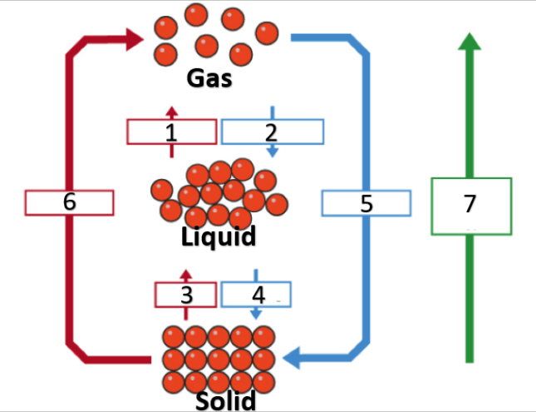
2 | Condensation  Gas changing into a liquid
3 | Melting  Solid changing into a liquid
4 | Freezing  A liquid changing into a solid
5 | Deposition  A gas changing into a solid
6 | Sublimation  A solid changing into a gas
7 | Increasing energy  Energy is added to the substance

- Mixtures & pure substances
Pure substances | Mixtures
Contains one type of particle | Contains particles that are not all the same
Cannot be separated | Can be separated
Has a fixed boiling and melting point | Has a boiling and melting temperature range
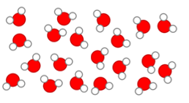 | 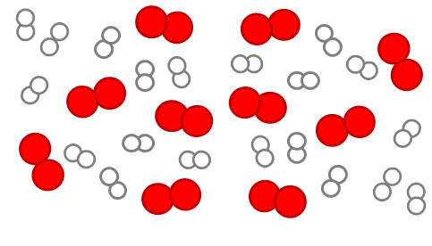

- Solubility Key Words
Solute | A substance that dissolves to make a solution
Solvent | A substance that dissolves a solute
Solution | A substance that is a mixture of a solvent and a solute
Solubility | A measure of how well a substance will dissolve
Insoluble | A substance that will not dissolve
Saturated solution | When the maximum amount of solute has dissolved and no more is able to dissolve

Science: Particles and Separation Techniques
- Filtration
Separates: an insoluble solid from a liquid
1 | Filter paper
2 | Funnel
3 | Residue (solid)
4 | Conical flask
6 | Filtrate (liquid)

- Evaporation
Separates: a soluble solid from a solution
1 | Evaporating basin
2 | Gauze
3 | Tripod
4 | Bunsen burner

Challenge questions
1 | Describe the arrangement of particles in the 3 states of matter
2 | Describe and explain how you could investigate the saturation point of different solutes
3 | Explain the difference between boiling and evaporation
4 | Explain the changes in energy and particle arrangement as ice is heated to steam.

- Distillation
Separates: a liquid from a solution
1 | Bunsen burner
2 | Solution
3 | Thermometer
4 | Water out
5 | Condenser
6 | Water in
7 | Beaker
8 | Separated liquid

- Chromatography
Separates: dissolved substances in a mixture
1 | Water
2 | Pencil base (start) line
3 | Ink spot
4 | Beaker
5 | Paper
6 | Separated dyes
7 | Solvent front

