Science: GCSE Organisation

- Digestive system
 | Organ | Function
1 | Oesophagus | Muscle contractions push food into the stomach
2 | Stomach | Hydrochloric acid and pepsin chemically digest food, stomach muscles churn the food.
3 | Liver | Produced bile that is added into the first part of the small intestines called the ileum
4 | Pancreas | Produces enzymes that are released into the small intestines to complete digestion.
5 | Small Intestines | Chemical digestion continues and small soluble molecules are absorbed into the blood
6 | Large intestines | Water is removed from the waste faeces and absorbed back into the blood
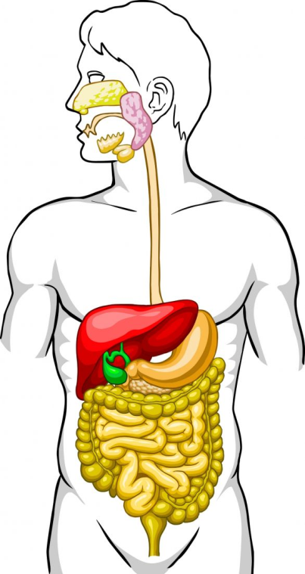
1
3
2
4
6
5

- Key words
Optimum | The best conditions for the reaction to take place fastest
Active site | The specific point in the structure of the enzyme where the reaction occurs
Denature | When the active site changes shape permanently so the enzyme no longer binds to the substrate
Emulsify | When fat droplets are broken down in to small ones to help mix them with the enzyme and increase the surface area for digestion
Bile | Alkali released from the liver in the duodenum to neutralise neutralise stomach acid and emulsify fats

- Enzymes
Enzymes are biological catalysts that speed up the digestion of large insoluble molecules to small soluble ones that can be absorbed into the blood.
Enzyme | Released from | Function
Amylase | Salivary Glands, pancreas and small Intestines | Breaks down starch into glucose
Protease (Pepsin) | Stomach (pepsin), pancreas and small intestines | Breaks down proteins into amino acids
Lipase | Pancreas and small intestines | Breaks down fats into fatty acids and glycerol

- Factors affecting the rate of an enzyme reaction
Temperature | pH | Concentration
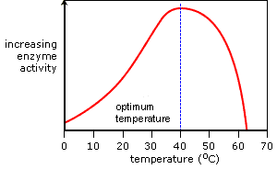 | 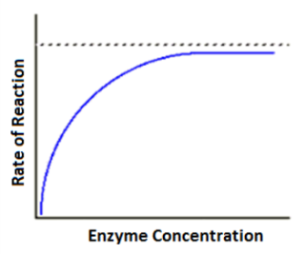
Science: GCSE Organisation

- Key Words
1 | Diaphragm | Flat muscle underneath the lungs that contracts and relaxes to cause breathing
2 | Trachea | Tube containing rings of cartilage that allows air to move in and out of the lungs
3 | Thorax | Air tight chest cavity containing the respiratory system and the heart.
4 | Alveoli | Small blind ending sacs where gases are exchanged between the air and the blood
3
4
1
2
Inhaling |  |  | Exhaling
Diaphragm contracts |  |  | Diaphragm relaxes
Volume in the thorax increases |  |  | Volume in the thorax decreases
Pressure in the thorax decreases |  |  | Pressure in the thorax increases
Air is pulled into the lungs |  |  | Air is pushed out of the lungs

Challenge Questions
1 | Why does boiled amylase not work when cooled down to room temperature?
2 | How and why does asthma affect breathing?
3 | How are the lungs adapted for gas exchange?
4 | Why is both diffusion and active transport needed to absorb digested nutrients into the blood?

- Circulatory system
 | Key Word
1 | Vena cava | Vein that brings deoxygenated blood back to the heart from the body
2 | Right atrium | Pumps blood in to the ventricle and where the pacemaker cells are located
3 | Right ventricle | Pimps blood out of the heat to the lungs
4 | Pulmonary artery | Takes deoxygenated blood to the lungs
5 | Pulmonary vein | Brings oxygenated blood back to the heart from the lungs
6 | Left atrium | Pumps blood to the left atrium
7 | Left ventricle | Pumps blood out of the heart to the body. Has a large muscle wall to pump blood at a high pressure
8 | Aorta | Artery that carries blood away from the heart to the body
9 | Valves | These prevent the backflow of blood through the circulatory system
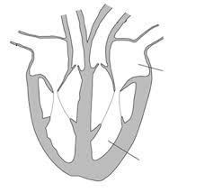
The blood flows through the heart in the order of 1 to 8
4
2
3
7
9
6
5
8
1

Science: GCSE Organisation

- Non communicable diseases
Non-communicable disease | Condition that is caused by lifestyle and is not spread by a pathogen
Risk Factor | Environmental or lifestyle factor that can increase the likelihood of developing a non-communicable disease
Coronary Heart Disease | Condition where fat (cholesterol) builds up in the coronary arteries, reducing blood flow to the heart muscles
Diabetes | Condition where the pancreas cannot make enough or does not make any insulin to control blood sugar levels
Deficiency disease | Condition caused by a lack of a specific nutrient, mineral or vitamin, e.g. anaemia or scurvy.

- Treating Coronary Heart Disease
Treatment | How it works | Advantages | Disadvantages
Statins | Breaks down cholesterol in the body | Reduces risk of heart attack by up to 35%, reduces likelihood of developing CHD | Side effects include headaches, memory loss and liver damage
Aspirin or Warfarin | Thins the blood and prevents blood clots | Aspirin can be bought cheaply at supermarkets | Increased risk of strokes if a blood vessel bursts and it cannot clot
Stent | Metal mesh that widens the blood vessel to increase blood flow | Increases blood flow to the heart reducing the chance of heart attacks | Temporary solution as cholesterol can build up over the stent
Heart bypass | Blood vessels from the leg are grafted over a narrow or blocked blood vessel | Several blockages could be treated at once. | Risk of infections from surgery

- Blood composition and Blood Vessels
 | Blood Vessel | Structural Adaptations
1 | Artery | Small lumen and thick muscular walls to withstand and maintain a high blood pressure
2 | Vein | Large lumen to increase the volume of blood in the blood vessel. Valves to prevent the back flow of blood
3 | Capillary | Thin calls that are only 1 cell thick to decrease the diffusion pathway and speed up exchange of substances
1
2
3
Component |  | Function
Plasma |  | Carries dissolved substances around the body including CO₂, urea, glucose, minerals, hormones and amino acids
Red blood cell |  | Carry oxygen from the lungs to the body cells
White blood cells |  | Internal defence against infection
Platelets |  | Causes the blood to clot around a wound

- Cancer
Benign tumour | Grows slowly inside a membrane and can be removed easily, does not invade other parts of the body
Malignant tumour | Grows rapidly and out of control. Cells can break off and travel in the blood to other parts of body to spread the cancer.

Challenge Questions
1 | What are the risk factors for cancer?
2 | Why do arteries need to maintain a high blood pressure?
3 | What lifestyle changes could be made to reduce the risk of developing a non-communicable disease and why is it hard to make everyone follow this?
4 | Evaluate the treatments for CHD for an 80 year old and for a 55 year old.

