Science: GCSE Organic Chemistry

- Key Words
Hydrocarbon | Compound made up of only carbon and hydrogen atoms
Alkane | Saturated hydrocarbon containing only single bonds between the atoms
Alkene | Unsaturated hydrocarbon containing at least one double bond
Cracking | A process that uses high temperatures and a catalyst to break down long chain alkanes into smaller alkanes and alkenes making more useful products
Fractional Distillation | A process of separating the different chain lengths of hydrocarbons found in crude oil
Crude oil | Fossil fuel made from the remains of dead plants and sea creatures millions of years ago and contains a millions of years ago, containing a mixture of different hydrocarbons

- Properties of Hydrocarbons
Viscosity | This refers to the thickness of the liquid hydrocarbon. As the length of the hydrocarbon chain increases, the viscosity increases and the liquid compound becomes thicker
Boiling point | This refers to the temperature at which the liquid hydrocarbon changes into a gas. The longer the hydrocarbon chain, the higher the boiling point
Flammable | This refers to how easily the hydrocarbon sets on fire. The smaller the hydrocarbon chain the more flammable it is

Challenge Questions
1 | How is crude oil formed?
2 | Why would hexane be an unsuitable fuel for cars?
3 | How could you investigate the effects of temperature on the viscosity of a hydrocarbon?
4 | Research some uses of simple alkenes (ethane to hexane)

- Alkanes
General Formula |  | C_{n}H_{2n+2}
Alkane name | Alkane formula |  | Alkane structure
Methane | CH₄
Ethane | C₂H₆
Propane | C₃H₈
Butane | C₄H₁₀
Pentane | C₅H₁₂
Hexane | C₆H₁₄

Science: GCSE Organic Chemistry

- Fractional Distillation
- In a furnace, crude oil is heated until it boils.
- The vapour then passes into the fractionating column which cools as it moves up the column.
- Those hydrocarbons with the highest boiling points condense first and are extracted.
- This continues up the column
 | Fraction and chain length | Use
1 | Fuel gas (C 1 – 4) | In camper stoves and gas bottles
2 | Petrol (C 5 – 10) | Used as fuel in cars
3 | Kerosene (C 10 – 16) | Used a fuel for aeroplanes
4 | Diesel (C 14 – 20) | Used as fuel for cars and lorries
5 | Lubricating oil (C 20 – 50) | Used in making oils, waxes and polishes
6 | Bitumen (C 70+) | Used to tar roads and felt roofs
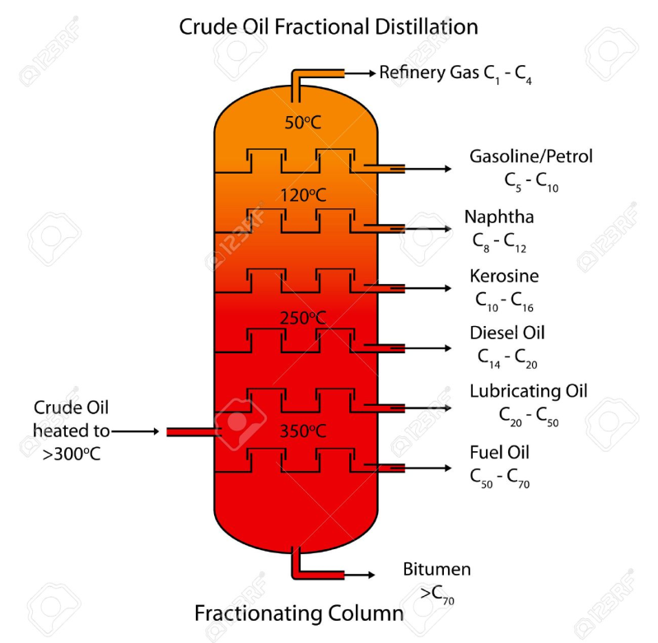
6
5
4
3
2
1

- Alkenes and Cracking
Formula of alkenes | C_{n}H_{2n}
Alkanes contain a double bond between one of the carbon –carbon bonds
e.g. propene

Cracking: Most hydrocarbons produce products with limited or no use. Cracking allows the large chain hydrocarbons to be broken down into useful products.
Conditions needed for cracking | Temperatures between 450 - 700˚C  A catalyst called zeolite which contains aluminium oxide and silicon oxide
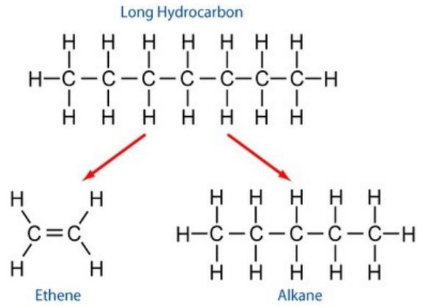
Testing for the presence of alkenes | Adding bromine water to the sample. If the sample turns colourless, then the sample is an alkene.

