Key Vocabulary
Term | Definition
Theme | The main idea in a piece of music. This is the most recognisable part of the music.
Variation | The theme but slightly changed. This could be changed through tempo, dynamics, timbre etc.
Motif | A small idea of music, often catchy and memorable.
Timbre | The sound quality from an instrument/group of instruments.
Structure | The layout of a piece of music.
Tempo | The speed of a piece of music.
Pitch | How high or low an instrument sounds.
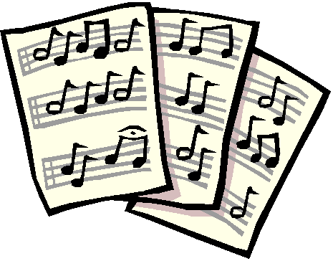
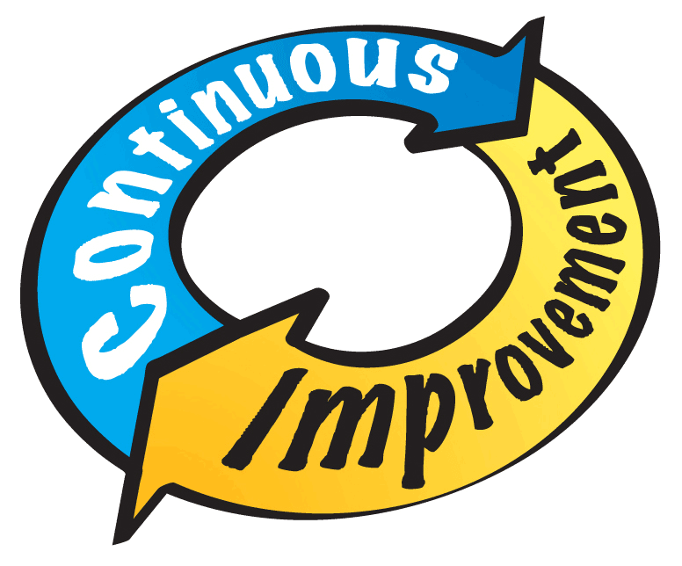
ACTIVITY
Whilst playing a video game, whether this be on Xbox, PlayStation, PC or on your Phone, listen for a motif (See Vocabulary Section) how many times does this repeat? Why do you think that is? Does this motif change?
Video Game music often uses this kind of structure as composers need to write music for hours and hours to go alongside the game.
Theme and Variation is a structure that has been used in music which dates back to 1538! This is the first known published music in the format of theme and variation.
Your music must match the brief that you have set!
Take your time when composing – your first idea might not be the best!
Make sure you have headphones in when using the keyboard
YEAR 7- TERM ONE- KNOWLEDGE ORGANISER - MUSIC
Always listen to the ideas of others as well as voicing your own
Deeper Learning

FEEDBACK
Positive and Developmental
“I liked their use of…”
“They could improve their work by…”
LINKING IMAGES
How can these images represent a musical feature?
CHARACTER BUILDING
Composing, Performing and collaborative work.
COMPOSITION
The process followed to create a piece of music.
PERFORMING
Improvisation or Devised
Meta Cognition
Always Remember
Focus, focus, focus!
Your work can always be improved

