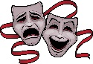Download Free png Performing arts png 2 » PNG Image - DLPNG.com

As you create your performance piece always refer back to your aim/ purpose. Does the piece fit?

Throughout the creative process always think about your target audience. Does your piece work for them?

Does the opening have impact? Have you gripped your audience?

Explore your chosen theme/ topic with workshops and activities before you start to create the final piece

Always build a team with likeminded people that will work hard and do their best

Use the ideas of everyone in the group

Always Remember (When part of a Production Company)

**Knowledge Organiser**

**Performing Arts – Autumn Term**

What is the Performing Arts?

Different forms of art are explored separately or combined together to create performance work. The most common are drama, dance and music.

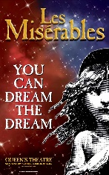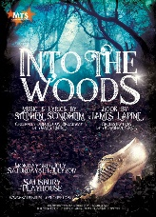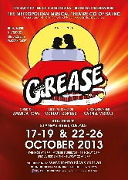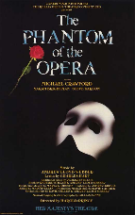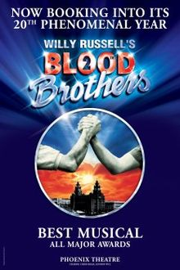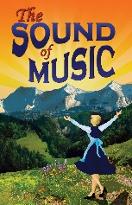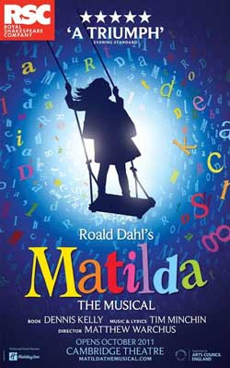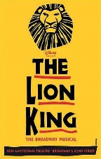See the source imageSee the source image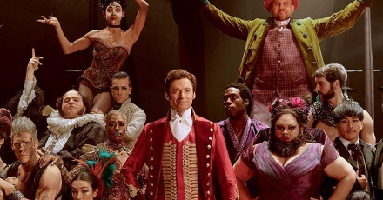Important clipart fact, Important fact Transparent FREE for ...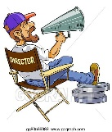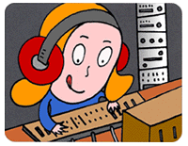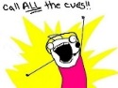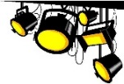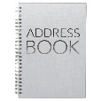Don't Make These Common Mistakes When Designing Your Small ...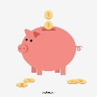Movie Svg Clapper Board Svg Cinema Svg Movie Slate dxf Film | Etsy

If you decide to study musical theatre to a greater depth there are a number of career paths that will be open to you, such as:

Actor, Teacher, Lecturer, Choreographer, Stage Manager, Musical Director, Acting Director, Singer, Musician, Professional Dancer, Private Coach, Casting Director, Make up artist, Playwright, Costume Designer, Sound Engineer or Lighting Technician to name a few!!

Where do you go from here?

Every musical has **Libretto,** which is the overall text including the spoken and sung parts. It also has the **Lyrics,** which are the words to the songs.

Songs are either **action** songs which move the plot forward or **character** songs which enable a character to express their feelings.

The amount of songs versus spoken dialogue vary from one musical to the next.

Key Points to Remember

Catchy music in a popular style.

Solo songs, duets, choruses and ensembles.

Orchestra or band accompaniment.

Spoken dialogue

Dance sequences, stage spectacles and eye catching costumes.

Key Features of Musical Theatre

Musical Theatre combines song, spoken dialogue, acting and dance.

Musical Theatre originated in Ancient Greece.

The ‘musical’ was invented by a French composer called ‘Herve’ when he was experimenting with a form of comic musical theatre he called ‘Operette’.

The Phantom of the Opera is the most successful musical of all time.

Musical Theatre Facts

**What will I need?**

A creative name

A theatre specialism

To advertise

A pot of money to start

Develop a business plan

Build a website

Acquire Equipment

Build contacts

Find a space to work

Use the strengths of my team

Playwright

Choreographer

Set designers

Understudies

Performers

Sound Designers

Stage Manager

Lighting Designers

Puppet Designers

Costume Designers

Directors

Technicians

Musicians

Roles within a Production Company

Starting a Production Company