   



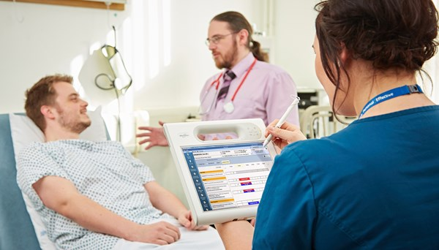

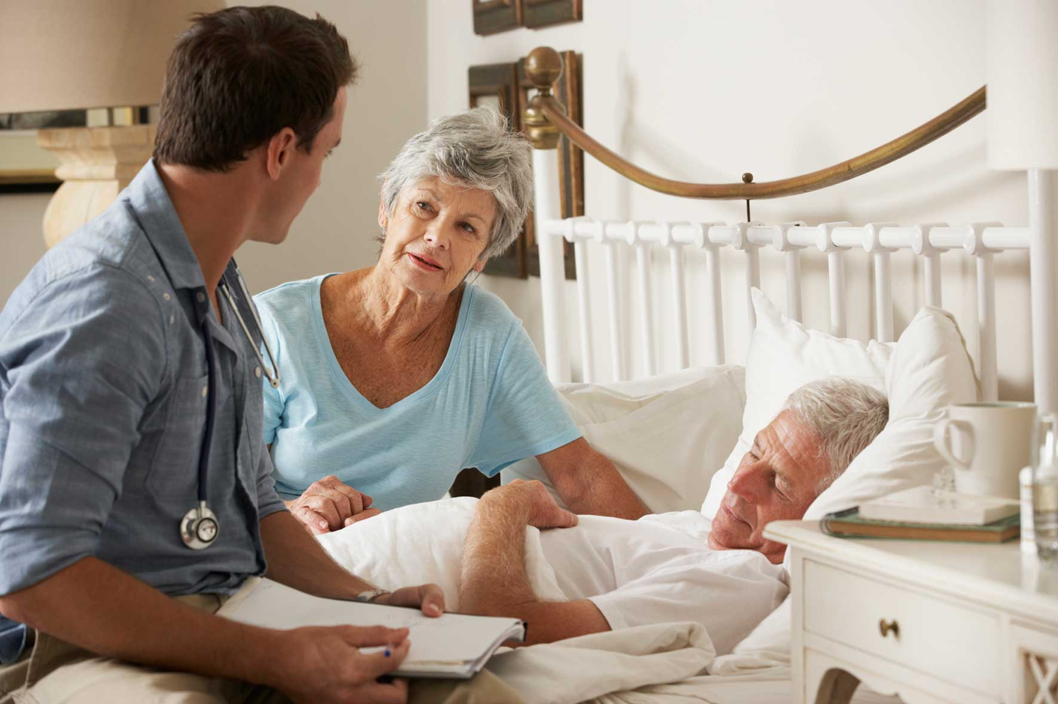

**Tertiary Care**: Where a person needs more than secondary care can offer.

* Spinal
* Cardiac
* Cancer
* Chronic Pain
* Burns
* Neonatal
* Rehabilitation
* Palliative
* Hospice

Health and Social Care Services may specialise in different life-stages or conditions and illnesses to meet the basic needs for all individuals.

**Foster Care:** Provides a stable home for children that cannot live with their families.

Residential Care: Some children or adults may need to move into residential care

Personal Assistants, Support Workers: Support in peoples own homes or to access facilities in the community.

Informal Care: Support from families or friends that is not paid work but they want to help or care for the individual, for example do their shopping, cleaning, take them out, give medication.

Allied health Care – Support through all stages of care from diagnosis to recovery

  
.

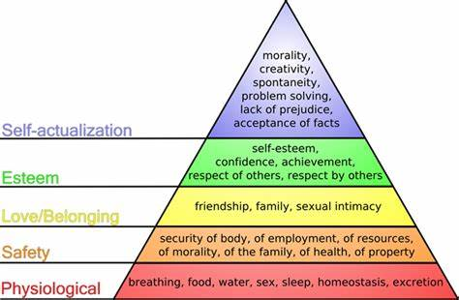

[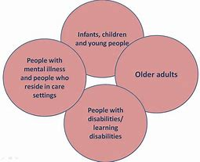](https://www.bing.com/images/search?view=detailV2&ccid=sLz3qYVf&id=41E4BD457B77387035EACE5CC89B6D22D57BCB58&thid=OIP.sLz3qYVf0UkAWxWGhdDcxAHaGC&mediaurl=https%3a%2f%2fvivienneclark.files.wordpress.com%2f2011%2f05%2fvulnerable-groups.png&exph=772&expw=947&q=how+health+and+socail+care+services+meet+the+PIES+needs+of+individuals&simid=608043729810752584&ck=CC481FA04A4A6A8E2ABE14367BCF285B&selectedIndex=16)

Formal Assessment: P1, P2, M1, D1: **Analyse how health and social care services meet individual needs and assess the barriers they may face and ways they are overcome.**



Ways to overcome barriers

Use of adapted equipment or aids

Additional adult support

Change the environment for example Move to a quiet place

Use of visuals, signs and translators.

Home visits from professionals, use of ICT, community centres

Additional resources

Help with finances and budgeting skills

Training.

**Barriers to access**

* **Physical for example** issues getting into and around the facilities
* **Sensory** for example hearing and visual difficulties
* **Social, cultural and psychological** for example lack of awareness, differing cultural beliefs, social stigma, fear of loss of independence
* **language** for example differing first language, language impairments
* **Geographical for example** distance of service provider, poor transport links
* **Intellectual** barriers for example learning difficulties
* **Resource** for service provider for example staff shortages, lack of local funding, high local demand
* **Financia**l for example charging for services, cost of transport, loss of income while accessing services.

**Social Care**

Secondary Care: Referred from primary care for further test, treatment

* Cardiology (Heart)
* Gynaecology (Female reproduction)
* Endocrinology (Endocrine glands and hormones)
* Urology (Male and female urinary tract and male reproductive organs)
* Paediatrics (Children)
* Ophthalmology (eyes)
* Obstetrics (Childbirth and midwifery)
* Psychiatrist (Mental Health)
* Respiratory (Breathing)
* Neurology (Brain, spinal cord and nerves)
* Gastroenterology Digestive system)
* Haematology (Blood)
* Orthopaedics (Bones, joints and soft tissues)
* Dermatology (Skin

**Voluntary Services - also referred to as charities and they are NOT funded through tax but by donations from the public and businesses.**



**Primary Care Services - - often the first point of contact for an individual for all ages for both mental and physical health needs**

**A1: Understand the different types of Health and Social Care services and the barriers to accessing them**

|  |
| --- |
|  |

**Nding**