Rights

* The right to be different
* Freedom from discrimination
* Confidentiality
* Choice
* Dignity
* Effective communication
* Safety and security
* Protection from harm, danger and abuse.
* Respect
* Privacy
* Have visitors

**B2 Reviewing own application of care values**

You will have the opportunity to visit different health and care settings and meet a variety of different professions. You will reflect on own application of care values, including using teacher or

service-user feedback.

You will keep a reflective journal to reflect through documenting ideas, feelings, observations, feedback and visions.

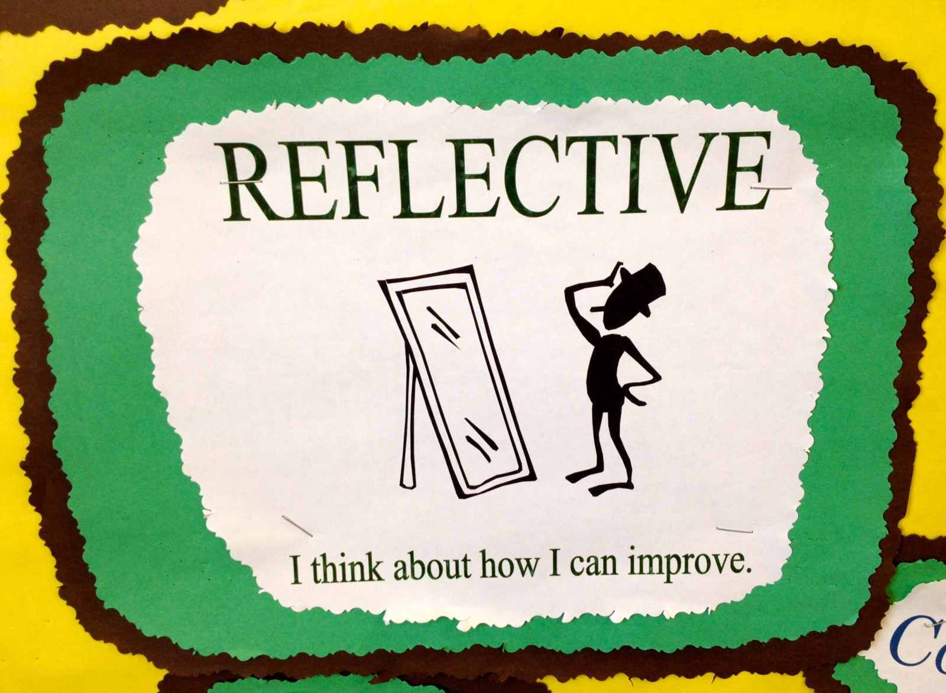

**Care Values**

* Empowering and promoting independence by involving individuals, where possible,  
  in making choices, for example about treatments they receive or about how care is delivered
* Respect for the individual by respecting service users’ needs, beliefs and identity
* Maintaining confidentiality; avoiding sharing information inappropriately, security of recording systems, the need and right to know.
* Preserving the dignity of individuals to help them maintain privacy and self-respect
* Effective communication that displays empathy and warmth
* Safeguarding and duty of care, for example maintaining a healthy and safe environment,  
  keeping individuals safe from physical harm
* Promoting anti-discriminatory practice by being aware of types of unfair  
  discrimination and avoiding discriminatory behaviour.

  

P3, P4, M2, D2: Formal Assessment: Demonstrate the care values independently in a health or social care context, making justified and appropriate recommendations for improvements of own application of the care values that incorporate feedback.



**LO2 B: Demonstrate care values and review own practice.**

Providing good health and social care services is very important and a set of ‘care values’ exists to ensure that this happens. Care values are important because they enable people who use health and social care services to get the care they need and to be protected from different sorts of harm.

|  |
| --- |
|  |

**Nding**