**Social Class**

Social class effects the development of children in numerous ways. Low social class effects the health, well-being and education of the parents, all fundamental factors in the development of young people. Young people are often taught to fit in with their social class, thus developing a personality that correlates with their social status. In school, teachers may give special opportunities to certain groups and often have higher expectations of children from higher social classes. There is no evidence to suggest that children from lower social classes have lower IQ’s, though it is well known that they may have fewer education opportunities, for example, fewer books, poorer access to technology and the internet. Social class of parents has been linked to their educational attainment, which will affect the aspirations and expectations parents will have for their own children, resulting in reduced social mobility and transit between classes, especially for the offspring of lower social class parents.

**Stress**

 Stress commonly causes or exacerbates illnesses. Stress has been linked to the development of problems such as high blood pressure, coronary artery disease, and is thought to ‘switch on’ genetic markers for other diseases. People living with a chronic disease, for example, muscular skeletal problems or respiratory disease, often find that the symptoms of their disease are heightened when suffering stress.

Before adulthood people’s tolerance for stress is lower and often need other people to help them regulate the amount of stress that they are exposed to. For the young person, too much stress can ‘overload’ the nervous system, leading to emotional and behavioural difficulties. It is not uncommon for young people when exposed to stress to regress to earlier and less advanced developmental stages.

**Housing**

Children living in poor, cramped accommodation can experience disturbed sleep, hyperactivity, poor diet, bedwetting and soiling, aggression and higher rates of accidents and infectious disease.

**Genetic Disorders**

**Coeliac disease**

Person cannot digest gluten. Gluten causes immune system to attack lining of small intestine. May require dietary control/gluten-free diet

**Cystic Fibrosis**

Caused by defective gene – a damaged gene that doesn’t work properly. It leads to production of defective protein causing mucus production in lungs, pancreas & intestines. This causes problems breathing.

**Rheumatic disease**

Covers a wide range of disorders involving inflammation of joints, ligaments, bones & muscles. Rheumatoid arthritis affects approx. 8/1000 in UK – increased risk through genetics.

**Asthma**

Airways become swollen, Can be caused by genetics. With most genetic diseases, people can normally lead a healthy life but their needs may differ.

It is very common for childhood illnesses to result in periods away from school which effects opportunities for learning, socialising and playing and making friends with other children. If a young person is not able to do some of the things that other children do, for example going to parties or playing sports they may feel different to other children, and perhaps become isolated and feel frustrated and angry.

**Effects of a poor diet**

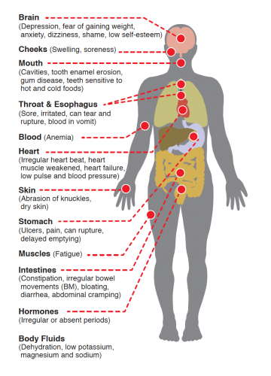

 [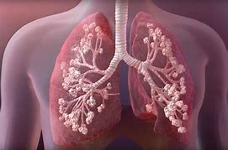](https://www.bing.com/images/search?view=detailV2&ccid=M/e%2brQku&id=9915256DC2AB98C8301A3AEC8F6AEA040B93CBFF&thid=OIP.M_e-rQkuYToRpjut1HQncwHaE8&mediaurl=https://3c1703fe8d.site.internapcdn.net/newman/gfx/news/2019/discoverycou.jpg&exph=500&expw=750&q=cystic+fibrosis&simid=608053938721393348&ck=51DDE7C8794F4B9728AF2E1795FED2E2&selectedIndex=2)

Delayed development - When a child’s development lags behind the developmental norms or developmental milestones for his her age. This can be caused by:- Brain damage, Poor social interaction with carers, genetic disorders, Visual disability, Hearing disability, Poor nutrition.

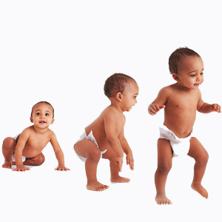

P2 Explain how different factors have affected growth and development of a selected individual. M1 Compare the different factors that have affected growth and development across three life stages for a selected individual D1 Assess the changing impact of different factors in the growth and development across three life stages of a selected individual. (To include 2 from physical and Social and 1 from cultural).

|  |
| --- |
| **3. Social, Cultural and emotional factors** a) Educational experiences b) Culture, e.g. community involvement, religion, gender c) Influence of role models d) Influence of social isolation e) Personal relationship with friends and family |
|  |

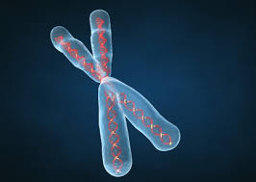 

**A2 –Factors affecting growth and development**

|  |
| --- |
|  |

**Nding**

|  |
| --- |
| **1. Physical factors** a) Genetic inheritance b) Diet and lifestyle choices c) Experience of illness and disease d) Appearance ) |
| **2. Economic factors a) Income/ wealth b) Material possessions** |

**Milestones - A significant event or stage in life, progress, development**. **Life Expectancy- How long people are expected to live Life Course - The path of the human cycle.**

**Lifestages**1. Infancy (0 – 2 years) 2. Early childhood (3 – 8 years) 3. Adolescence (9 – 18 years) 4.. Early adulthood (19 – 45 years) 5. Middle adulthood (46 – 65 years)  
6. Later adulthood (65+ years

**Physical, Intellectual, Emotional, Social Development (PIES)**