Feeling safe, secure, able to express self, be respected, having a positive self-concept, friendships and strong family relationships.

Comes from keeping the brain healthy and active through opportunities to learning, skills, communication and problem solving.

**Milestones - A significant event or stage in life, progress, development**.

**Lifestages**1. Infancy (0 – 2 years) 2. Early childhood (3 – 8 years) 3. Adolescence (9 – 18 years) 4.. Early adulthood (19 – 45 years) 5. Middle adulthood (46 – 65 years)  
6. Later adulthood (65+ years).

**The whole person - Physical, Intellectual, Emotional, Social Development (PIES) Remember health and well- being is about meeting the needs of the whole person. (Holistic approach).**

**Physical Health – Healthy body systems, regular exercise, a healthy diet, regular sleep patterns, good personal hygiene, access to shelter and warmth**

P1: Extended Write: Describe the physical, intellectual, emotional and social development for 3 life stages for a chosen individual and explain how one area of development can impact another area of development

**Older Adulthood**

Ageing process is very slow, some people only notice changes in their 60’s.

Thinner and less sensitive skin.

Wrinkles.

Bones more brittle.

Stiffer joints.

Reduced height and some bending.

Weaker muscles.

Less balance

Senses and breathing less effective.

High blood pressure.

Less insulin produced.

[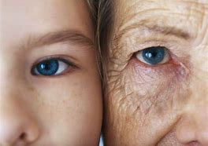](https://www.bing.com/images/search?view=detailV2&ccid=5cbdP7qE&id=D43CA6D41DB3F76613FA32DA5062433BF43A307B&thid=OIP.5cbdP7qEdIZZ6D2YpfaaawHaFj&mediaurl=https://1800healthaws-u0v4hwfdhnovjcr0vl6.netdna-ssl.com/wp-content/uploads/2016/03/face-old-lady.jpeg&exph=1536&expw=2048&q=+changes+to+the+body+bones+and+skin+for+older+peoepel&simid=607986091209917000&ck=01021C644CFFF3248A33BAC187E0275E&selectedIndex=9)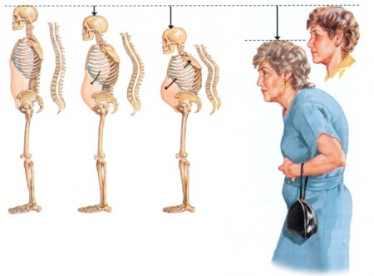

**A1 – How do people grow and develop throughout their lives?**

|  |
| --- |
|  |

**Nding**

**Adulthood**

Young adults often have no responsibility and can go out and spend their money as they like. What social activities would they do?

Most adults have to balancetheir social life with work and family responsibilities.

**As their children get older they have more time and money to spend on themselves**

Adolescence

It becomes important to fit in with a peer group (a group of people who are the same age and very important to an individual). They also start to experiment with sexual relationships.

They depend on peer advice, and feel they need to be accepted by their peers which mean they can change their clothes, interests and behaviour.

Some may even go as far as to behave in a wrong way, just to fit in. For example?

**Infancy**

Likes to please adults and to perform for an audience

May become anxious or distressed if separated from known adults

May use comfort object

Mostly cooperative and can be distracted from unwanted behaviour

Plays alongside other children

**Childhood**

Makes friends but may need help in resolving disputes

Developing understanding of rules, but still finds turn-taking difficult

Enjoys helping others and taking responsibility

Learns lots about the world and how it works, and about people and relationships

Makes friends (often short-term) and plays group games

Needs structure and a routine to feel safe

When behaviour is ‘over the top’, they need limits to be set

**Infancy**

Language development – babbling, sounds, words

**Childhood**

**Language development, imaginative, recognition, understanding.**

Adolescence

**Brain continues to develop, there are still many differences in how a middle aged adolescent thinks compared to an adult.**

**Adulthood**

Job, independence, learning new skills.

**Social and Emotional Development**

**Intellectual Development**

WeightGrowth

**Adolescence - Female**

**Adolescence - Male**

reflexes

Weight, growth,

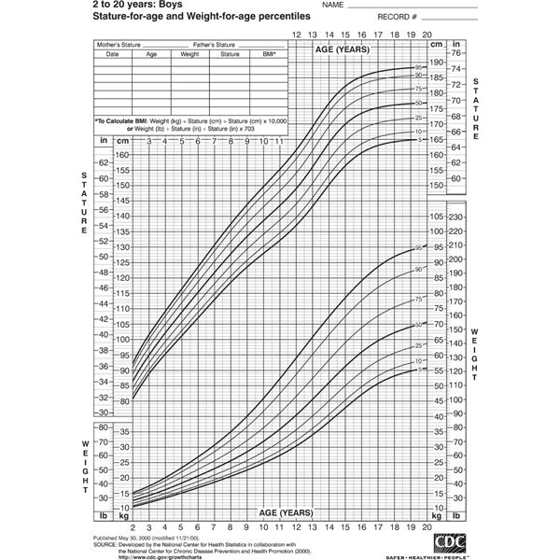



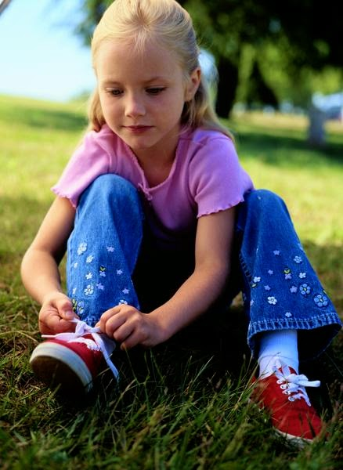

Childhood (Physical) Gross and fine motor skills.

Infancy (Physical)

**Adulthood 19 - 65**

Fully mature but tend to gain weight. Women usually experience menopause (the natural and permanent stopping of menstruation between; 45-55.

Men may lose hair.

Hair often starts to grey.

Eyesight may deteriorate.

The skin loses elasticity and wrinkles appear.

Female fertility decreases and ends with the menopause.

Sperm reproduction decreases.

