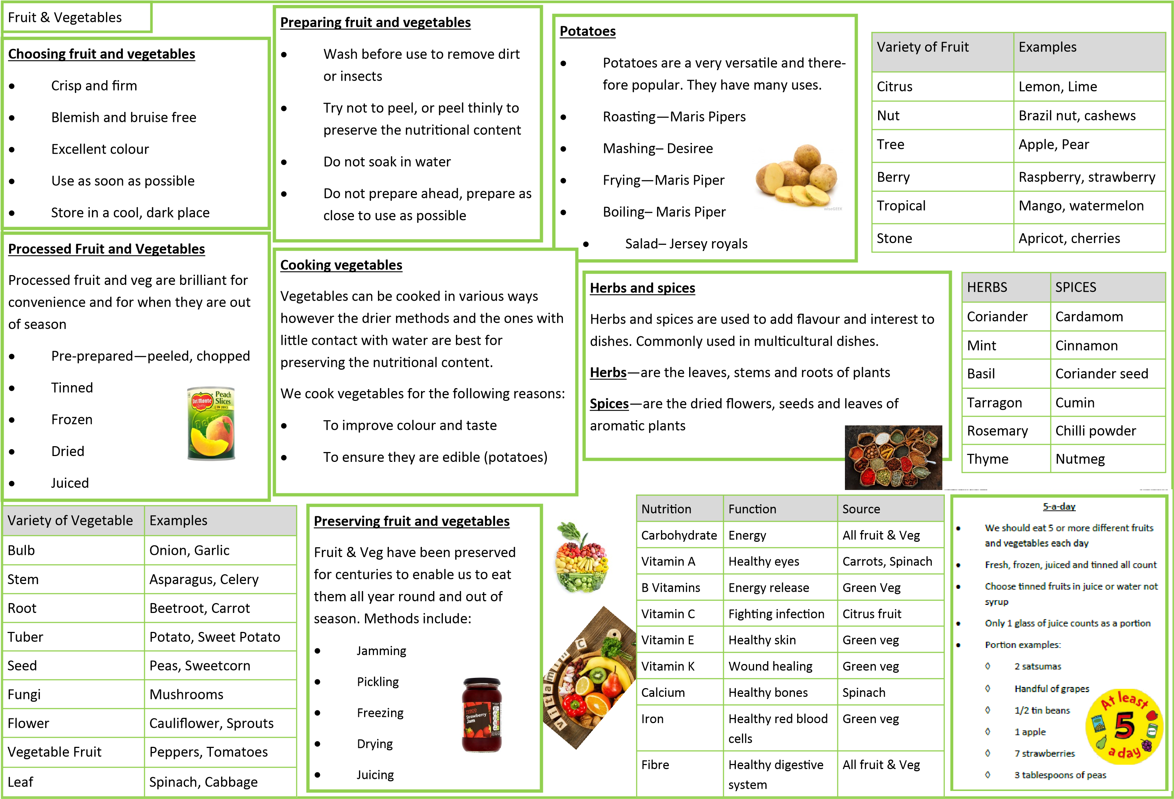

KNOWLEDGE ORGANISER AUTUMN TERM 1 yr10