Science: Cell Biology
Science: Cell Biology

- Key Words
 | Organelle | Function
1 | Nucleus | Controls the cell  Contains genetic material
2 | Cell membrane | Controls the exchange of substances in and out of the cell
3 | Ribosomes | Protein synthesis
4 | Cytoplasm | Where chemical reactions occur
5 | Mitochondria | Releases energy from aerobic respiration
6 | Cell wall | Supports the cell
7 | Chloroplasts | Where photosynthesis occurs
8 | Vacuole | Contains cell sap
9 | Plasmid | Circular ring of DNA
10 | flagella | Provides movement for single celled organisms
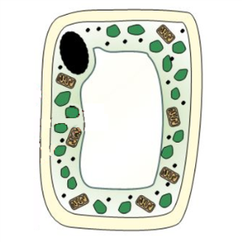
Eukaryotes (complex cells)
6
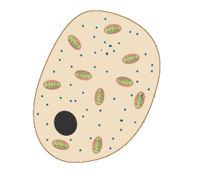
1
2
7
3
8
4
Plant Cell
Animal Cell
5

Prokaryotes (simple cells – bacteria)
9
6
10
2
3

4
DNA (genetic material

- Specialised Cells
Cell | Function | Adaptation
Sperm cell | Fertilised the egg cell | - Tail to swim to egg  - Many mitochondria to release energy
Nerve cell | Carry electrical impulses around the body | - Long to reduce the number of synapses  - Lots of branches to connect to many cells
Muscle cell | Contracts and relaxes to cause movement | - Many mitochondria to release energy  - Contains protein fibres that can contract
Root hair cell | Absorbs water and minerals from the soil | - Large surface area to increase absorption  - No chloroplasts to allow a larger vacuole
Palisade cell | Where most photosynthesis occurs | - Many chloroplasts, so more photosynthesis  - Rectangular shape to fit more cells along the upper surface of the leaf
Phloem cell | Transports sugars, ions and other minerals around the plant | - Many mitochondria to release energy for active transport  - Perforated ends so cytoplasm of adjacent cells connect speeding up exchange
Xylem cell | Transports water from the root to the leaves. | - Contains lignin to prevent water loss  - Hollow so water and minerals can travel through

- Comparing microscopes
Type | Advantages | Disadvantages
Light Microscope | - Can see colours  - Cheaper  - Can see live specimens | - Lower magnification  - Lower resolution
Electron Microscope | - Higher resolution  - Higher magnification | - Cannot see colour  - Only see dead specimens
Conversions:

Science: Cell Biology
Science: Cell Biology

- Calculating magnification

- Cell differentiation and stem cells
Differentiation | When a stem cell changes into a specialised cell
Stem cells | Cells that have not differentiated yet
Adult stem cells | Stem cells found in body tissues such as skin and bone marrow
Embryonic stem cells | Stem cells from the embryo that have the potential to turn in to any type of specialised cells
Meristems | Tips of the roots and shoot where the plant stem cells are found
Chromosomes | Condensed strand of DNA containing the genes for characteristics (23 pairs in humans)
Cell cycle | The process where the cell divides
Mitosis | A type of cell division that produced 2 identical diploid daughter cells
Therapeutic cloning | Creating a cloned embryo to have the same genetics as the patient to treat genetic diseases.

- Stages of the cell cycle (mitosis in lilac)
1 | Organelles are copied and DNA condenses into chromosomes | 4  3  2  1
2 | Chromosome number doubles and nuclear membrane dissolves
3 | Chromosomes line up along the centre and duplicate chromosomes are pulled apart
4 | Cell membrane closes around each set of chromosomes (cytokinesis) and 2 identical cells are formed

- Types of exchange
Key Word | Definition | Example
Diffusion | Movement of solutes from a high to a low concentration across a semi-permeable membrane | Oxygen and carbon dioxide exchanged in the lungs
Osmosis | Movement of water from a low to high concentration across a semi-permeable membrane | Water moving into the blood in the large intestine or into the roots of a plant
Active transport | Movement of solutes from a low to a high concentration against a concentration, requiring energy | Minerals moving into the root hair cells and sugars moving in to the blood in the small intestines

Challenge Questions
1 | Why do prokaryotes not contain mitochondria?
2 | Compare and contrast plant, animal and prokaryotic cells.
3 | Using a Venn diagram, compare and contrast diffusion, osmosis and active transport.
4 | Evaluate the use of adult stem cells and embryonic stem cells to treat patients

