Science: GCSE Atomic Structure and the Periodic Table

- Structure of the atom
 | Key word |  | Definition
1 | Atom |  | The smallest possible piece of an element. Has a radius of 0.1nm (or 1x10-10m)
2 | Nucleus |  | The centre of an atom. Contains protons and neutrons
3 | Proton |  | A positively charged particle found in the nucleus
4 | Neutron |  | A neutral particle found in the nucleus. Has no charge
5 | Electron |  | A negatively charged particle found in energy levels (shells) around the nucleus
6 | Shell |  | Energy levels surrounding the nucleus of the atom
Sub-atomic particle |  | Relative atomic mass |  | Charge | 6  5  2  3  4
Proton |  | 1 |  | +1
Neutron |  | 1 |  | 0
Electron |  | ~0 |  | -1

- Key Words
Atomic number | Number of protons in the nucleus of an atom
Atomic mass | Total number of protons and neutrons in the nucleus of an atom
Isotope | Different forms of the same element with the same number of protons, but different numbers of neutrons
Ion | A charged atom that forms when electrons are lost or gained

- Discovery of the Atomic Model
 | Model | Discovery
1 | Solid sphere | Dalton stated that the atom was the smallest particle and it could not be broken up further
2 | Plum Pudding  Discovery of the electron | JJ Thompson stated that the atom was a cloud of positive charge with negatively charged electrons randomly dotted around the cloud.
3 | Nuclear model  Discovery of a positively charged nucleus | Rutherford conducted experiments with gold foil that proved that the atom contained a positively charged nucleus with the electrons randomly around the outside of the nucleus
4 | Planetary Model (Bohr)  Discovery that electrons orbit the nucleus on energy levels called ‘shells’ | Bohr stated that electrons orbited around the nucleus like planets around the sun and that there were different numbers of shells in different elements
5 | Quantum Model  Discovered that electrons are found in clouds of probability called orbitals | Schrodinger stated that electrons do not orbit the nucleus but move around in waves and it is impossible to know the exact location of an electron.
6 | Modern Atomic Model  Discovery of the neutron | Chadwick discovered the neutron in the nucleus which helped to explain the atomic mass of an atom.
1 2 3 4 5 6
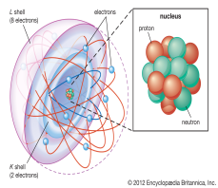

- Properties of metals and non-metals
Metals | Non-Metals
High density, sonorous, malleable, shiny, conducts heat and electricity | Low density, brittle, dull, poor conductors of heat and electricity

Science: GCSE Atomic Structure and the Periodic Table

- Electron configuration diagrams
Rules | - Do not draw protons and neutrons in the nucleus  - Use small x’s to show electrons  - Only 2 electrons can fit on the 1st shell, then 8 on 2nd, 8 on 3rd  - Draw the electrons from the nucleus outward
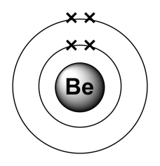  Beryllium |  | 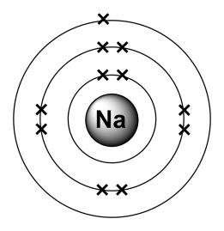  Sodium

- The Periodic Table
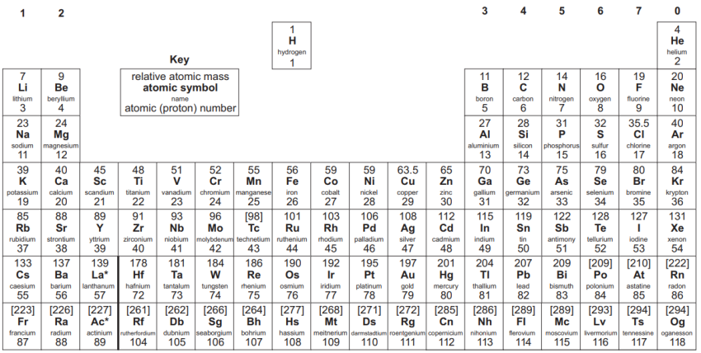
Developed by Mendeleev, who arranged the elements in order of atomic mass. He left gaps for undiscovered elements and predicted their properties. When these predictions proved correct, Mendeleev’s periodic table was widely accepted.
Arrangement | Elements are placed in order based on atomic number
Groups | The columns downwards: Elements in each group have similar properties and electronic configurations
Periods | The rows across: Elements in the same period have the same number of shells.
Transition metals | Highlighted in yellow are the transition metals of the periodic table. These elements can form more than one type of ion.

- Patterns in the periodic table
Group | Name | Elements | Key feature | Patterns
1 | Alkali metals | Li, Na, K, Rb, Cs, Fr | Contains 1 electron on the outer shell | Reactivity increases down the group and atom gets bigger
7 | Halogens | F, Cl, I, Br | Contain 7 electrons on the outer shell | Reactivity decreases down the group and atom gets bigger
0 | Nobel Gases | He, Ne, Ar, Kr, Xe, Rn | All atoms have a full outer shell | Unreactive elements (inert)

- Forming ions
Rules | Positively charged ions have lost electrons from the outer shell  Negatively charged ions have gained electrons from the outer shell
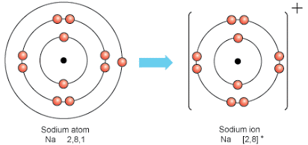  Sodium (Na⁺) |  | 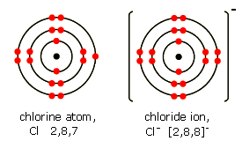  Chlorine (Cl⁻)

Challenge Questions
1 | Draw an electron configuration diagram for Fluorine and calculate the number of protons, neutrons and electrons.
2 | Compare the plum pudding model to the Bohr model of the atom
3 | Explain how Rutherford’s gold foil experiments disproved the plum pudding model
4 | Explain in detail the patterns in reactivity for group 1 and 7.

