Science: GCSE Atomic Structure and Radiation

- Structure of the atom
 | Key word |  | Definition
1 | Atom |  | The smallest possible piece of an element. Has a radius of 0.1nm (or 1x10-10m)
2 | Nucleus |  | The centre of an atom. Contains protons and neutrons
3 | Proton |  | A positively charged particle found in the nucleus
4 | Neutron |  | A neutral particle found in the nucleus. Has no charge
5 | Electron |  | A negatively charged particle found in energy levels (shells) around the nucleus
Sub-atomic particle |  | Relative atomic mass |  | Charge | 5  2  3  4
Proton |  | 1 |  | +1
Neutron |  | 1 |  | 0
Electron |  | ~0 |  | -1

- Key Words
Atomic number | Number of protons in the nucleus of an atom
Atomic mass | Total number of protons and neutrons in the nucleus of an atom
Isotope | Different forms of the same element with the same number of protons, but different numbers of neutrons

- Discovery of the Atomic Model
 | Model | Discovery
1 | Solid sphere | Dalton stated that the atom was the smallest particle and it could not be broken up further
2 | Plum Pudding  Discovery of the electron | JJ Thompson stated that the atom was a cloud of positive charge with negatively charged electrons randomly dotted around the cloud.
3 | Nuclear model  Discovery of a positively charged nucleus | Rutherford conducted experiments with gold foil that proved that the atom contained a positively charged nucleus with the electrons randomly around the outside of the nucleus
4 | Planetary Model (Bohr)  Discovery that electrons orbit the nucleus on energy levels called ‘shells’ | Bohr stated that electrons orbited around the nucleus like planets around the sun and that there were different numbers of shells in different elements
5 | Quantum Model  Discovered that electrons are found in clouds of probability called orbitals | Schrodinger stated that electrons do not orbit the nucleus but move around in waves and it is impossible to know the exact location of an electron.
6 | Modern Atomic Model  Discovery of the neutron | Chadwick discovered the neutron in the nucleus which helped to explain the atomic mass of an atom.
1 2 3 4 5 6
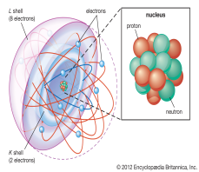

Challenge Questions
1 | What needs to be taken before the count rate can be measured?
2 | What safety precautions should a teacher take when demonstrating radioactive sources to the class?
3 | Explain why isotopes of large elements are generally radioactive.
4 | Explain why a radioactive source with a short half-life is used as tracers in the body?

Science: GCSE Atomic Structure and Radiation

- Radiactivity Key Words
Background radiation | Radiation that is found in the environment such as from rocks, cosmic rays and fallout from nuclear weapons testing
Becquerel (Bq) | Units for measuring the radioactivity of a source
Count rate | The speed at which a radioactive source decays (gives out radiation)
Unstable atom | An atom that a very large nucleus with a high neutron to proton ration meaning that radiation is emitted from the nucleus
Geiger counter | Instrument used to measure radioactivity of a substance

- Types of Radiation
Type of radiation | Symbol | Structure and charge | Range and penetration | Ionising power
Alpha | α | 2 protons and 2 neutrons from the nucleus  Charge = +2 | Travels up to 5cm in air, blocked by paper and skin | High
Beta | β | Fast moving electron from the nucleus  Charge = -1 | Most travel up to 15cm in air, blocked by a thin sheet of aluminium | Medium
Gamma | γ | High energy wave  Charge = 0 | Can travel at the speed of light so can travel vast distances. Stopped by 1m thick concrete or thick lead plates | Low

- Half-Life
The half-life of a radioactive source is the time it takes for the count rate to decrease by half.
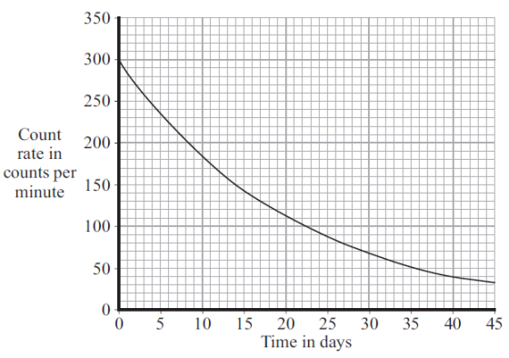 | - The starting count rate is 300, so half of that is 150.  - You find 150 on the y-axis and read across to the line.  - Then read down from the line to calculate the time.  So for this graph, the half-life is 15 days.  This means that every 15 days the count rate will decrease by half.  In 60 days the count rate will be 18.75Bq

- Half-life Equations (HT)
Alpha decay | When an alpha particle is emitted from the nucleus 2 protons and 2 neutrons are given out. This means the atomic number will decrease by 2 and the atomic mass will decrease by 4.
beta decay | When a beta particle is emitted from an atom, 1 neutron changes into a proton. This means the atomic number will increase by 1 and the atomic mass will stay the same.

