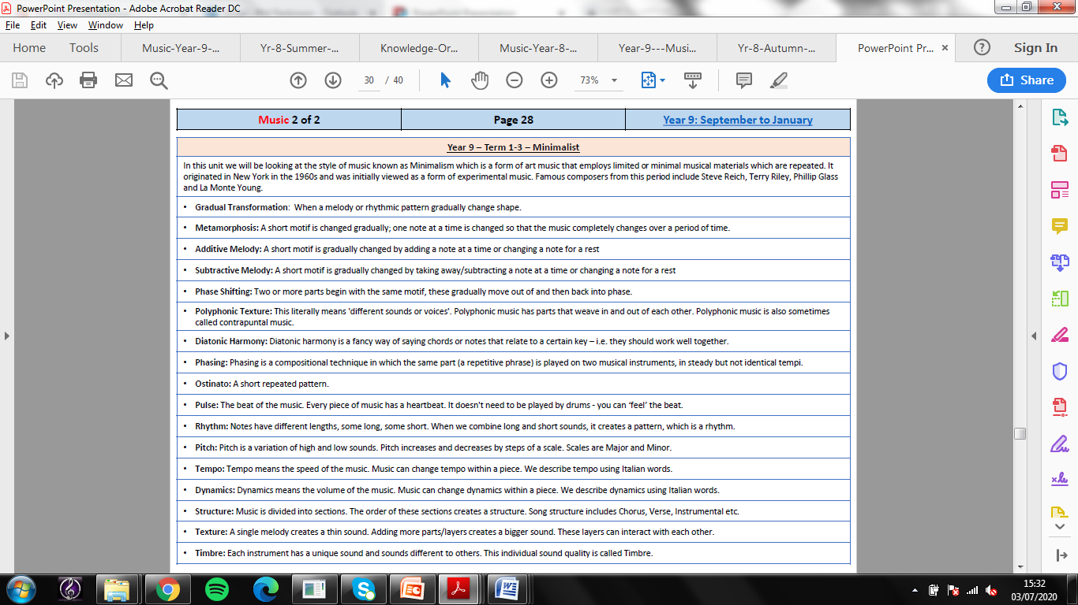

**Key Terminology**

**Year 11 HT 1 – Area of Study 4 Knowledge Organiser**